**UTC2720 Income Inequality: A Teleological Perspective**

Professor Venkat Venkatasubramanian

AY2018/2019 Special Term 2

**Income Inequality - A Tale of Five Countries**

A study on the inequality in income distribution in Norway, the United States, Singapore, Malaysia, and the United Kingdom

Joseph Ong A0189953H

Hannah Chia En A0187209X

Gnaneshwar Rao Gopinath Rao A0184298M

**Contents**

1. **Introduction …………………………………………………....……… 3**
2. **Comparison between Norway and the United States …………….… 3**
3. **Singapore ……….………………………………………………...…… 9**
4. **Malaysia ……….…………………………………....…...……………. 13**
5. **United Kingdom ……………………………………………………… 17**
6. **Conclusion ……………………………………………………………. 22**

**1. Introduction**

The paper will analyse and compare the income shares for the top 1%, bottom 90% and middle 10-1% for the pre-tax and post-wage income data for Norway, USA, Singapore, Malaysia and the UK and how they differ from the actual data from ideal society. We will start by comparing Norway and the USA, which lies on the opposite ends of the spectrum in regards to how close their income distributions are to the ideal society. Afterwards, we will analyse the distributions of Singapore, Malaysia and the UK individually and examine where they lie on the spectrum.

**2. Comparisons between Norway and the United States of America**

In Bhuvai, the income distribution follows the ideal lognormal distribution. The nonideal inequality coefficient, ψ, which measures the level of nonideal inequality in the system is zero. In theory, when plotted in a graph, the income distributions of the top 1%, top 10-1% and bottom 90% should all be a flat line with a zero ψ value. A positive ψ value indicates that the income share is more than ideal. Conversely, a negative ψ value indicates a less than ideal income share.

As expected, none of the five countries, Norway, USA, Singapore, Malaysia and UK follow this ideal income distribution. However, Norway comes remarkably close to ideal as shown in its pre-tax income distribution below:

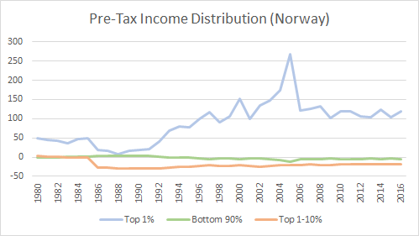

*Figure 2.1*: Pre-tax income distribution (Norway)

As seen in the graph above, its bottom 90% and top 10-1% income shares, as shown by the green and orange lines, have been relatively close to the ideal Bhuvai values over the last ~40 years. This is a surprising result, as Norway did not know what the ideal, theoretically fairest distribution was, and yet seemed to have “discovered” and maintained a near-ideal outcome empirically on its own. However, the income distribution is not entirely ideal. Unlike the bottom 99% ψ values, the top 1% ψ value are far above the ideal, averaging about 100% in the last 10 years.

At the start in 1980, the top 1% ψ value is around 45% while the top 10-1% and bottom 90% are very close to 0%. In 1988, the top 1% ψ value has decreased close to zero, the top 10-1% has fallen to about -28% while the bottom 90% has maintained close to zero. The income distribution reached its most unequal state in 2005, where the top 1% ψ value rose to over 250%, the top 10-1% has risen to about -20% and the bottom 90% has fallen to -12%. Afterwards from 2006 onwards, the values have stabilised, with the top 1% ψ value at about 100%, the top 10-1% at -20% and the bottom 90% at -5%. In this state, a majority of the population (90%) receive near ideal income shares.

On the other end of the spectrum lies the USA, where out of the five countries, its pre-tax income distribution deviates the greatest from the ideal distribution.

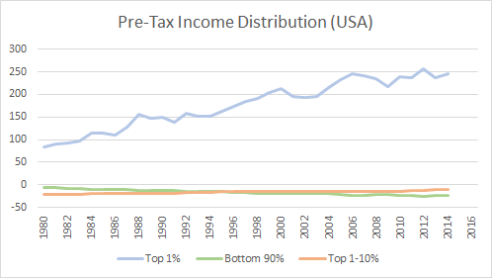

*Figure 2.2*: Pre-tax income distribution (USA)

As seen in the graph above, the gap between the top 10% and the bottom 90% have been continuously rising over the 40 year time period. In 1980, the income distribution is very similar to Norway’s near ideal levels of inequality, where the top 1% ψ value is around 80%, the top 10-1% around -21% and the bottom 90% around -6%. However, the inequality gap has steadily increased in the next 40 years, with the top 1% ψ value nearly tripling to around 250%, the top 10-1% rising -10% and the bottom 90% falling by almost five times to around -25%. The decades of rising inequality have been referred to as the “Great Divergence” by Krugman and journalist Timothy Noah.

Both countries also differ in the effects on tax on income distributions. The before and after tax distributions for the top 1%, top 1-10% and bottom 90% for both countries can be seen below:

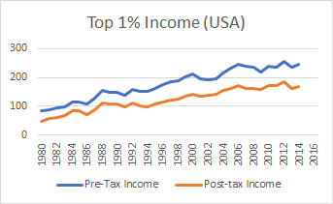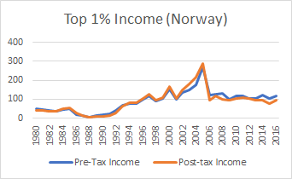

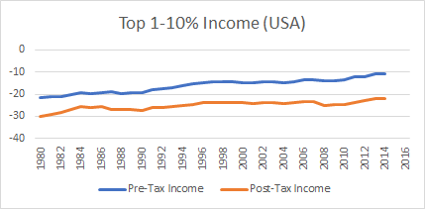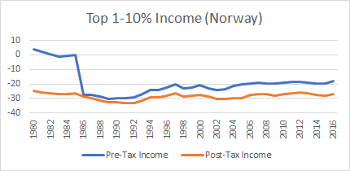

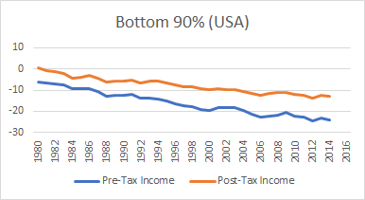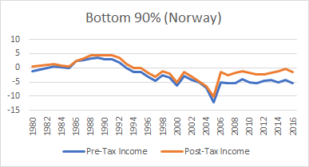

*Figure 2.3*: Comparisons of pre- and post-tax distribution for the top 1%, top 1-10% and bottom 90% income (USA & Norway)

Comparing both sets of graphs, there are two observations:

1. USA’s tax policies have a clear effect in reducing income inequality across all three income groups, bringing the ψ values closer to zero. However, Norway’s taxes appear to have achieved mixed results. Taxes on the top 1% has little to no effect on the ψ value, as shown by the pre- and post- tax graphs which are almost overlapping each other. The taxes on the top 10-1% actually causes the already negative ψ value to increase, worsening income inequality. For the bottom 90%, the past 10 years of taxes have brought the already low negative ψ values to almost zero values.
2. Despite the USA's tax policies doing more to reduce income inequality across the three income groups, USA still lags greatly behind Norway in fairness of income distribution.

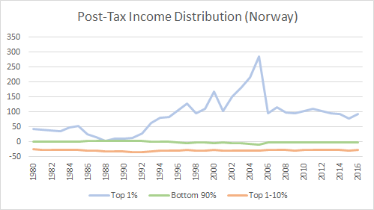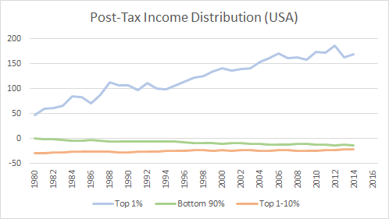

*Figure 2.4*: Graphs of the post-tax income distribution (Norway & USA)

As shown above, when both post-tax income distributions are compared side to side, Norway has near perfect and sustained ψ values for the bottom 90% of the population, whereas USA has huge income inequality gaps between the top 1% and the bottom 99%, with the gap continuing to rise.

Globalisation is often cited as a major factor in the global trend of rising income inequalities. However, unlike the USA, Norway and other countries such as Germany and Sweden have experienced the same increase in trade without experiencing as large an increase in income inequality. This suggests that while globalisation does places pressure on inequality, institutional factors such as unionisation, minimum wage and tax rates play a greater role in explaining the differences in the two countries[1].

One key institutional factor is the difference in how the societies perceive fairness[2] and their economic systems. A significantly larger share of Americans hold a libertarian fairness view, where they consider inequalities due to luck and inequalities due to differences in productivity fair, whereas a larger share of Norwenians hold an egalitarian view where they consider all inequalities unfair[3]. This could be the reason why both countries have very different economic systems. While both countries embrace capitalism, the USA follows “cutthroat capitalism”, assigning more weight to efficiency and economic growth relative to fairness, while Norway follows the Nordic model, a socialist welfare economy that prioritises welfare and fairness in income distribution. This results in different policies and objectives, leading to the different inequalities in income distribution seen.

One key area where both countries differ in are the levels of unionisation, which could explain the differences in ψ values for the bottom 90%. Norway has a high degree of unionisation, featuring multi-level collective bargaining with strong tripartite partnerships between employees, trade unions and the government[4]. More than half of the employees are in trade unions, with evidence showing that increased union density in Norway have led to substantial increased firm productivity and wages for the average worker[5]. On the other hand, USA’s private sector unionization rates have fallen to an all time low, weakening workers bargaining power and causing the real minimum wage to fall to about a third lower than it was almost 50 years ago[6]. America has gone the longest period in history without an increase in federal wage, which was last increased to $7.25/hour in 2009, raising public scrutiny and concerns over the growing inequality.

With regards to the top 1% ψ value, Norway appears to have stabilised in the last 10 years, while the USA’s has been rising rapidly. The rapid rise is due to the incredibly high CEO to average employee pay ratios, which have skyrocketed from the 25-40 range in the 1970s to more than 300 in recent years[7]. This rise is not due to the free market, but due to increased managerial power, poor corporate governance, lack of effective arms-length bargaining and greed[8].

While USA’s tax policies have brought all three income groups closer to ideality, it does not help close the widening gap between the top 1% and the bottom 99%. Taxes could be more progressive, however this is unlikely considering that the current Trump administration is in favour for lowering taxes in a way that arguably benefits the wealthy disproportionately, furthering exacerbating the existing income inequality[9]. In comparison, Norway has a significantly higher tax level and a more generous welfare state[10] which has resulted in 90% of the population achieving near ideal income shares. It can be argued that it is much more costly for the USA than for Norway to implement comprehensive welfare systems, as the USA is the world’s driver of innovation and economic growth[11].

However, one similarity between Norway and the USA is that the ψ values for the top 1% are more than 100%. This is the same for Singapore, Malaysia and UK. On paper, this looks alarming as the deviation is huge from ideality, which raises questions on whether such deviations are acceptable. On one hand, it can be argued that the top 1% holding such a large share of income is a natural by-product of a successful market economy. It suggests the presence of firms of large scale and size which are able to contribute back to the economy through investments and employment. On the other hand, cases like USA where the income share of the top 1% is continually growing at the expense of the bottom 90% reveal systemic failures in the system and are a huge source of inequalities in the country.

**3. Singapore**

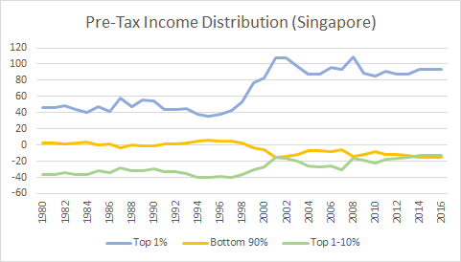

*Figure 3.1*: Pre-tax income distribution (Singapore)

In Singapore’s history of income distribution and inequality, the past 40 years has first seen a period of stability, with 90% of the population possessing almost-ideal income shares. At the 1996-year mark, this stability is then followed by a period of relatively drastic change. The income distribution ultimately stabilises yet again from 2002 onwards, with an increased degree of equality as seen from the increase in the phi value for the bottom 90%. Accordingly, these three broad time periods will be examined individually in a bid to find an explanation for these trends.

***1980 - 1996: Stable income distribution, with 90% of the population attaining almost-ideal income shares***

Following Singapore’s independence in 1965, Singapore witnessed constant GDP growth over the years after its independence[12], and successfully raised income levels ‘sixfold’[13] from then till 1996.

Singapore’s growth was primarily founded on its role as an international trade center and operation as a free port. This meant that Singapore’s economic performance was heavily reliant on that of the global market. Thus, Singapore thrived in periods of growing international trade, but likewise, suffered when world trade witnessed ‘minor downturns’[14], an example of which being the recession in 1985-1986. Singapore’s dependence on the global market, an area over which it had ‘little control’[15], pushed the government to strictly regulate ‘domestic conditions’[16]. This started with the People’s Action Party maintaining a strong hold over the government and hence on the power to enforce policies that aligned with their strategy for economic growth.

In the government’s efforts to ‘present a more favourable climate for foreign investment’[17], they not only subdued the ‘serious labour unrest’[18] of the 1950s and 1960s, but further complemented this with welfare provisions such as bringing ‘new jobs to the private sector’[19] and providing subsidized ‘housing, education, health services, and public transportation’[20]. This was a possible explanation for how 90% of the population managed to attain an almost-ideal share of income over this period of post-independence development, with the phi value being almost, if not, at 0.

The National Trades Union Congress (NTUC) and National Wages Council (NWC) further served to offer opinions on wage negotiations and labour movements that would counter-balance that of the government. An example of the success of tripartism and thus multiplicity of perspectives involved in determining labour wages can be seen in the 1980s recession, where under NTUC’s guidance, unions ‘decided to forgo the 1985 wage increases recommended by the NWC’[21] and instead ‘accept cuts in [...] employers’ contributions to workers’ Central Provident Fund’[22], a move which has been credited by the government and business leaders to have contribution to Singapore’s ‘quick recovery from the recession’[23].

Thus, the strict domestic control exercised by the government in conjunction with space for input by trade unions might have resulted in an almost-ideal income distribution for a huge percentage of the population.

***1996 - 2002: A period of drastic change which sees marked deviation from the ideal distribution, in particular for the top 1%***

This period of drastic increase in income inequality in comparison to the previous years of distribution stability can possibly be attributed to the effects of the 1997 Asian Financial Crisis.

The government and the NWC, in seeing how the crisis was affecting other Asian economies, took preventative measures in the form of ‘recommended wage restraint guidelines’ and an ‘Off-Budget package’ intended to help ‘reduce business costs’[24], as well as tax rebates for properties and utilities. However, these measures could not prevent the eventual decline in Singapore’s economy, with productivity ‘[going] down by 2.5 percent and most sectors posting negative productivity growth’, ultimately resulting in ‘rapid’ retrenchments and unemployment[25].

In response to this, government agencies and trade unions called for ‘wage restraints’ in a bid to minimise retrenchment, which included restricting pay raises, ‘shorter work [weeks]’, and ‘temporary lay-offs’[26].

Despite the resulting decrease in shares for the middle 1-10%, these decisions resulted in the share of the bottom 90% noticeably increasing. Thus, the decisions made can be considered successful in mitigating the problem of income inequality that the crisis might have only exacerbated.

***2002 - 2016: Stability observed once more, with increased equality for 90% of the population***

2002 marks the year in which income distributions begin to stabilise once again. Despite the SARS crisis in 2003 further impacting Singapore’s tourism sector, which led to the temporary continuation of ‘severe wage restrictions’[27] as recommended by the NWC, they were lifted soon after, with the focus turning to ‘restructuring’ the wage system such that it was more ‘flexible’ and ‘performance-based’[28].

When the 2008 recession hit, the government along with the tripartite partners made decisions similar to those in 1997. This time, the income distribution remained relatively stable in comparison. This could potentially be attributed to the new wage systems that were a response to the 1997 crisis being successful in stabilising the income distribution in Singapore.

***Concluding Remarks***

With the exception of the top 10%, government intervention in Singapore therefore seems to prove itself beneficial in attaining and sustaining an almost-ideal distribution of inequality. This can be interpreted in the trends post-independence and prior to the 1997 crisis, and can be further backed up by how changes encouraged in the wage system in the 2000s resulted in stability in the subsequent 2008 crisis.

In making further comparisons between Singapore’s inequality and that of Norway and USA, we can see that Singapore’s distribution lies somewhere in between the two. This can perhaps be attributed to how the Singapore administration places greater emphasis than the USA in tackling the issue of income inequality[29], but yet holds tight to its key tenet of self-reliance and self-sufficiency in its citizens. Thus, social welfare expenditure is kept to a minimum[30], and schemes such as the Central Provident Fund and Workfare[31] are promoted in contrast to state pensions and a minimum wage as seen in the USA and Norway. In this way, Singapore seems to lie in the middle ground between the USA's form of cutthroat capitalism and Norway’s welfare socialism.

**4. Malaysia**

Unfortunately, the data that we were able to obtain on Malaysia’s income shares was sparse[32], thus resulting in gaps in our graphs of the respective ψ values. The ranges of consecutive years which we were able to obtain data for were 1984-1986, 1993-1995, 2000-2003, and 2009-2012 respectively. Trends in the ψ values over these years are thus depicted below.

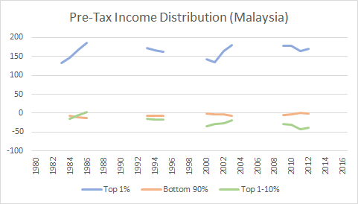

*Figure 4.1*: Pre-tax income distribution (Malaysia)

***1984-1986: A period of escalating inequality***

From 1984 to 1986, there is a stark increase in shares of the top 1% and a corresponding decrease in that of the bottom 99%, resulting in the phi value of the top 1% ‘s shares skyrocketing, that of the middle 1-10% increasing, and that of the bottom 90% decreasing.

This can be attributed to the ‘commodity shock’ that Malaysia’s economy faced in the mid-1980s, in which Malaysia’s ‘overall export price index declined by 30%’ and ‘terms of trade deteriorated by almost 20%’[33]. This in turn resulted in a rapid downturn in the economy, with the annual growth rate falling from 7% to -1% from 1980 to 1985, and in that of aggregate demand[34]. This resulted in the unemployment rate almost doubling[35], ultimately contributing to the falling shares of the bottom 90%.

***2000-2012: Almost-ideal distribution of shares for 90% of the population***

In the 2000s, the bottom 90% see a possession of shares that is almost, if not, aligned with the ideal income distribution, as seen from how the phi values of the bottom 90% lie extremely close to the ideal inequality line.

Leading up to 2000, the Malaysian government focused heavily on growing Malaysia’s economy, with Malaysia’s GDP rising to 59% in the 1990s with export-oriented industries making a recovery[36], and the per capita income doubling from 1990 to 1996[37]. There was also an increased focus on cultivating human capital through education, thus increasing the employability of the labour force. These multiple factors may have collaboratively resulted in the overall decrease of unequal income distribution for the bottom 90%, albeit at the expense of the middle 1-10%

The years of 2008 to 2012 was a period of recovery from the 2008 Global Financial Crisis. In attempts to protect Malaysia’s economy, the government announced a ‘60 billion ringgit economic-stimulus plan’ that ‘strain[ed] government finances’[38]. This was a clear instance of Malaysia’s commitment to government intervention in managing their economy.

Following this, it was in 2010 that Malaysia’s Prime Minister Najib Razak revealed Malaysia’s New Economic Model (NEM), with its key aim being to elevate Malaysia from a middle-income nation to a high-income one, all while sustaining the economic growth rate. This included a renewed focus on investing in human capital and increased reliance on the private sector. The increasing decentralisation in particular is believed to be a primary reason for Malaysia surpassing its goals for gross national income and GDP in 2012[39].

Despite this, the middle 1-10% appears to have suffered from the crisis, with their phi values being an at all-time low in our dataset. This can possibly be attributed to the income of the top 10% being heavily reliant on assets, which then depreciate in times of the crisis, thus resulting in a fall in their income shares.

Even so, with the sustained stability in income equality for 90% of the population as seen from their phi values hovering around the ideal inequality line, the management of the 2008 crisis can be seen as a mark of success for the Malaysian government’s economic intervention strategies.

***Concluding Remarks***

Malaysia’s economic structure has seen extensive government intervention, as seen from the high deficits in government expenditure from growing new industries[40] and protecting the country’s economy from financial crises in the past. As seen from how Malaysia has achieved an almost-ideal state of income distribution at times, the central planning exhibited conveys a certain degree of success. However, given the breaks in the data trends as well as the seemingly beneficial move towards decentralisation in the 2000s, it is hard to say definitively whether Malaysia’s income distribution would fared better with or without government intervention at times.

Regardless, when comparing with the other countries in this report as depicted in the following figures, Malaysia appears to be on the right track in its handling of income inequality, with the 90% of the population attaining almost-ideal and the fairest income shares as of the 2012 mark.

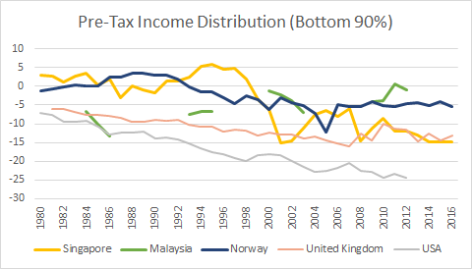  
*Figure 4.3:* Pre-tax income distribution of bottom 90% (Singapore, Malaysia, Norway, UK, and USA combined)

**5. United Kingdom**

***Pre-Tax Income Distribution of the United Kingdom, 1981-2016***

**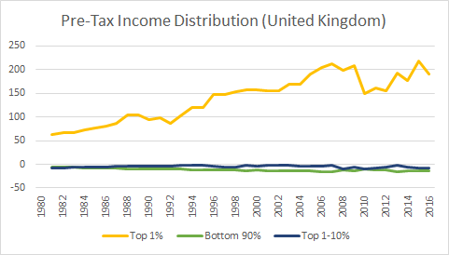***Figure 5.1:* Pre-tax income distribution (UK)

Based off the ψ values depicted in the above figure, the pre-tax income distribution in the UK appears to be almost ideal for 99% of the population.

The top 1% is an exception to this, exhibiting phi values that are markedly higher than that of the other two income groups. This can be attributed to a ‘rise in average income for the richest fifth’ and yet ‘a fall in income’ for the ‘poorest fifth’[41]. This divergence has generally gotten wider over the years, peaking at 13% in 2015 which coheres with the peak in ψ value above, which is almost double that of Norway’s which stands at 8%.

Around 2009 to 2011, however, we notice a drastic dip in shares of the top 1% despite shares of the other 99% remaining relatively stable. This could potentially be a result of changes to tax policies despite this income data being pre-tax, as with the advanced notice of a ‘50% additional rate of income tax’ being enacted in April 2010, it is possible that ‘high income individuals brought income forward into 2009/10 in order to pay less tax on it”[42].

***Post-Tax Income Distribution of the United Kingdom, 1981-2016***

Unlike the previous two case studies, we were able to obtain both pre-tax and post-tax income data for the UK.

*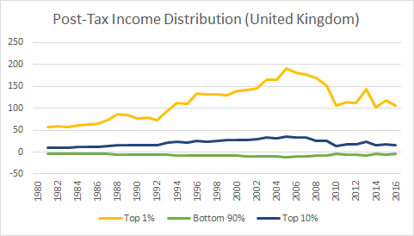  
Figure 5.2:* Post-tax income distribution (UK)

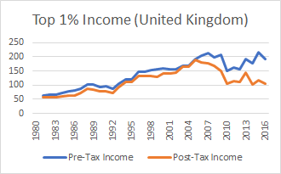*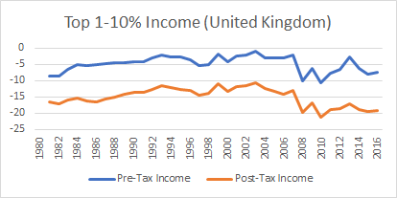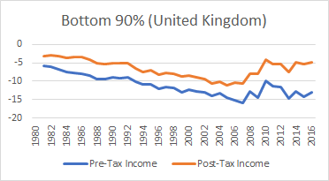  
Figure 5.3:* Comparisons of pre- and post-tax distribution for the top 1%, top 1-10% and bottom 90% income (UK)

In comparing the post-tax distribution to the pre-tax distribution for all three income groups, the general trends and disparities between the three groups appear to follow similar patterns up till the 2005-year mark.

From 2005, however, we can see that there is an increasing divergence between the ψ values of pre-tax and post-tax shares, for all three income groups and most drastically, for the top 1% (notwithstanding the peak in 2013 which can be attributed to yet another incidence of income-shifting similar to that in 2009/2010). This shows that with the effect of taxation, the income shares of a large majority of the population, i.e. the top 1% and bottom 90%, are gradually heading more and more towards the ideal level of inequality.

This can be attributed to the UK adopting increasingly progressive income tax regimes from 2000-2016, which implies that those were lower incomes are being taxed at a lower rate. Taxation rates for the lowest income groups has steadily fallen, with those earning ‘between £10,000 and £15,000 a year [...] see[-ing] their average rate of income tax fall [...] from 11.3% to 3.1%’[43]. Middle earners, considered to be those in the ‘£30,000 to £50,000 income group’, has seen a similar phenomenon with their income tax rate falling ‘from 19 to 13.5 per cent’[44].

Meanwhile, the top 1% saw ‘a rapid rise’ in average tax rates, due not only to the increasingly progressive tax regimes, but also to the 2010/2011 introduction of an additional tax band on the highest income groups. As of 2013/2014, those earning ‘£200,000 to £500,000’ were subject to a total tax rate of 37%[45].

All in all, the UK’s increasingly progressive tax regime might be the cause for the respective rise and fall in shares of the bottom 90% and top 1% from 2010 onwards.

However, there remains the odd case of the middle 1-10%, in which taxation policies has only served to increase the inequality in their shares as denoted by the further decrease in phi values post-tax. This perhaps hints at underlying issues in the distribution of tax brackets, resulting in the middle 1-10% being justifiably subjected to higher taxes due to their higher incomes, but yet at a disproportionate rate that should be examined and perhaps revised.

***Concluding Remarks***

Once again, it appears that in reality, where ideal free markets conditions are unrealistic, elusive, and cannot be counted on to achieve maximum fairness, government intervention succeeds in facilitating movement towards fairer income distribution. In comparison to the USA and Norway, taxation in the US appears to be generally lower than that of both countries, being only slightly lower than that of the USA. The UK and the USA’s similar tax regimes may be the reason for the graphically similar effects of tax on income shares in the pre-tax and post-tax comparison figures (Figure 2.3, Figure 5.3). Taking into consideration the initial pre-tax distributions for all three countries, however, the post-tax inequality witnessed in the UK continues to lie in between Norway and the USA for the most part with the UK faring better for the middle 1-10%, as depicted as such.

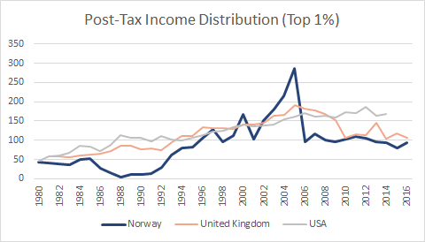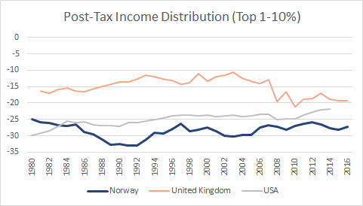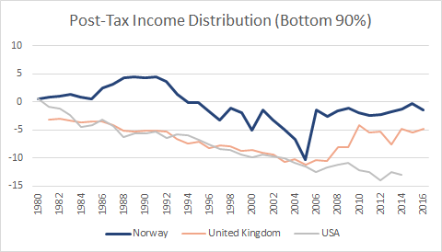

*Figure 6:* Comparisons of pre- and post-tax distribution for the top 1%, top 1-10% and bottom 90% income (Norway, UK, USA)

**6. Conclusion**

From our analysis of Norway, the USA, Singapore, Malaysia, and the UK, we have noticed certain interesting trends that prove themselves consistent across these five countries.

There is first the issue of the middle 1-10%, whose phi values lie consistently below the ideal inequality line and is often further subjected to increased inequality after accounting for the effects of taxation policies. This was a puzzling result that defied our expectations, given the high income shares of the middle 1-10% in comparison to the bottom 90% and the conventional consensus that the incomes of the top 10% are disproportionately and oftentimes unjustifiably high.

There is also the pronounced high phi values of the shares that the top 1% possess, which appear to be an integral and fairly immovable feature of the economic systems covered in this paper. This can possibly be defended by the rationale that the top 1% are important drivers and contributors to their country’s economy, and thus justified of their high income. However, this has also been proven to be untrue in some circumstances, as illuminated through prior research on the disproportionately high income levels of executives[46].

Furthermore, even if the high income shares of the top 1% were justified in relation to their contributions to the economy, to what extent can we as a society allow their shares to rise, especially if it is at the expense of a large majority of the population? This is the current situation faced in the USA as demonstrated above, with phi values of the top 1% escalating at the expense of the bottom 90%. This then raises the question of how income can be redistributed in a way that is fair to all - as stated by Adam Smith, ‘What improves the circumstances of the greater part can never be regarded as an inconveniency to the whole. No society can surely be flourishing and happy, of which the far greater part of the members are poor and miserable.’

1. Anderson, B., & Malloy, L. C. (Year written). Bargaining power and inequality in states with a globally exposed economy. Unpublished manuscript.
2. Alesina, A., Stantcheva, S., & Teso, E. (2018). Intergenerational mobility and preferences for redistribution. *American Economic Review, 108*(2), 521-554. doi:10.1257/aer.20162015
3. Almås, I., Cappelen, A. W., & Tungodden, B. (2019). Cutthroat capitalism versus cuddly socialism: Are americans more meritocratic and efficiency-seeking than scandinavians?*Journal of Political Economy,* doi:10.1086/705551
4. Nergaard, K. (2014). Trade unions in Norway coordinated wage bargaining and workplace level co-determination. Berlin: Friedrich-Ebert-Stiftung, Dep. for Central and Eastern Europe.
5. Barth, Erling, Bryson, & Harald. (2017, November 13). Union Density, Productivity and Wages. Retrieved from <https://papers.ssrn.com/sol3/papers.cfm?abstract_id=3069454>
6. Anderson, B., & Malloy, L. C. (Year written). Bargaining power and inequality in states with a globally exposed economy. Unpublished manuscript.
7. CEO Pay Continues to Rise as Typical Workers Are Paid Less. (n.d.). Retrieved from https://www.epi.org/publication/ceo-pay-continues-to-rise/
8. Fried, J., & Bebchuk, L. A. (2009). Pay Without Performance: The Unfulfilled Promise of Executive Compensation. Cambridge: Harvard University Press.
9. Rasmus, J., & Fars News Agency. (2019, May 01). How Trump Policies Exacerbate Income Inequality in America. Retrieved from https://www.globalresearch.ca/trump-policies-exacerbate-income-inequality-usa/5676136
10. Barth, Erling, Moene, Ove, K., Willumsen, & Fredrik. (1970, January 01). The Scandinavian model-An interpretation. Retrieved from https://econpapers.repec.org/article/eeepubeco/v_3a117_3ay_3a2014_3ai_3ac_3ap_3a60-72.htm
11. Acemoglu, Daron, Robinson, A, J., Verdier, & Thierry. (2012, October 11). Can't We All Be More Like Scandinavians? Asymmetric Growth and Institutions in an Interdependent World. Retrieved from https://www.nber.org/papers/w18441
12. Ministry of Trade and Industry. (1986). The Singapore economy: New directions. Singapore: Ministry of Trade & Industry, Republic of Singapore. Call no.: RSING 330.95957 SIN
13. Hays, J. (n.d.). ECONOMIC HISTORY OF SINGAPORE. Retrieved from http://factsanddetails.com/southeast-asia/Singapore/sub5_7c/entry-3782.html
14. ibid.
15. ibid.
16. ibid.
17. ibid.
18. ibid.
19. ibid.
20. ibid.
21. 1980s. (n.d.). Retrieved from https://www.ntuc.org.sg/wps/portal/up2/home/aboutntuc/whoweare/historyofntuc/historyofntucdetails?WCM_GLOBAL_CONTEXT=/content_library/ntuc/home/about ntuc/ntuc history/ed7dab00450fb0c9b87ffe96656b86bc
22. ibid.
23. ibid.
24. Tan, C. L. (2013). The story of NWC: 40 years of tripartite commitment and partnership. Singapore: Straits Times Press Pte.
25. ibid.
26. ibid.
27. ibid.
28. ibid.
29. INCOME GROWTH, DISTRIBUTION AND MOBILITY TRENDS IN SINGAPORE. (n.d.). Retrieved from https://www.mof.gov.sg/Resources/Feature-Articles/Income-Growth-Distribution-and-Mobility-Trends-in-Singapore
30. Lee, S. A., & Qian, J. (2017, October 02). The Evolving Singaporean Welfare State - Lee - 2017 - Social Policy & Administration - Wiley Online Library. Retrieved from https://onlinelibrary.wiley.com/doi/full/10.1111/spol.12339
31. Employee. (n.d.). Retrieved from https://www.workfare.gov.sg/Pages/Home.aspx
32. Malaysia – WID – World Inequality Database. (n.d.). Retrieved from https://wid.world/country/malaysia/
33. Athukorala, P. (1970, January 01). Malaysian Economy in Three Crises, by Prema-chandra Athukorala. Retrieved from https://ideas.repec.org/p/pas/papers/2010-12.html
34. ibid.
35. ibid.
36. "Economics, Business, and the Environment – GDP: GDP per capita, current US dollars". Earth Trends. Archived from the original on February 20, 2009.
37. Spaeth, A., & Lumpur, J. C. (2003, October 13). Retrieved from https://web.archive.org/web/20090317235536/http://www.time.com/time/asia/2003/mahathir/mahathir961209.html
38. Chew, E. (2009, March 11). Malaysia Stimulus Tops $16 Billion. Retrieved from https://www.wsj.com/articles/SB123667522312181571
39. IshYoBoy.com. (2014, November 08). DOWNLOAD ECONOMIC TRANSFORMATION PROGRAMME ANNUAL REPORT 2012. Retrieved from http://www.teraju.gov.my/download-economic-transformation-programme-annual-report-2012/?lang=en
40. Salleh, Awang (6 December 1985). "The Impact of Technological Development On the Political, Economic and Social Life In Malaysia". Universiti Utara Malaysia.
41. The Scale of Economic Inequality in the UK. (n.d.). Retrieved from https://www.equalitytrust.org.uk/scale-economic-inequality-uk
42. McGuinness, F., & Harari, D. (2019, May 20). Income inequality in the UK. Retrieved from https://researchbriefings.parliament.uk/ResearchBriefing/Summary/CBP-7484
43. Palin, A. (2015, July 09). Chart that tells a story - average income tax rates. Retrieved from https://www.ft.com/content/c81ff1a0-23ee-11e5-bd83-71cb60e8f08c
44. ibid.
45. ibid.
46. VENKATASUBRAMANIAN, V. (2019). HOW MUCH INEQUALITY IS FAIR?: Mathematical principles of a moral, optimal, and stable... capitalist society. S.l.: COLUMBIA UNIV PRESS.